- What is the heat source in a Down Drain System?
- Oil
- Propane
- Electricity
- Solar
- Is the Down Drain System and open or closed loop system?
- What heat transfer media does a Down Drain System use?
- Freon
- Glycol
- Water
- Esophageal Phlegm
- What is the biggest problem with a Down Drain System?
- Over heating
- Heat exchanger failure
- Freezing of component parts
- Antifreeze depletion
- True or False: A Down Drain System drains by gravity.
- True or False: A Down Drain System uses both a storage tank and a heat exchanger.
- True or False: A Down Drain System uses both gate valves and ball valves.
- True or False: A Down Drain System requires a pump.
- The Balance Point is defined as…
- The point at which the building in use would be able to support thermal comfort without the need for heating or cooling
- The point at which interior noise and exterior noise are in equilibrium.
- The point at which heating loads and cooling loads are such that they negate one another.
- The point at which flame and smoke are present in equal amounts.
- HVAC system components can be grouped into which 3 of the following categories…
- Source
- Diffusion
- Delivery
- Distribution
- Collection
- Return
- True or False: Cooling can be described as reverse heat flow.
- The term “coolth” is…
- Used in reference to a heat sink.
- A cooling mass used to chill interior space.
- A naturally occurring “cool” spot within the earth that cab be tapped for distribution.

- True or False: Absorption is a chemical process.
- True or False: Vapor compression is a mechanical process.
- What are the 3 major refrigeration approaches employed in buildings:
- Cross ventilation
- Evaporative cooling
- Absorption
- Vapor compression
- Vapor Expansion
- Naturally occurring heat sinks include which of the following:
- Outside air
- Outside soil
- On-site bodies of water
- The night sky
- Munster cheese
- True or False: Fire places are passive heating systems.
- RE: Fireplaces- The method of heat distribution is… (Choose 2)
- Conduction
- Radiation
- Enthalpy
- Convection
- Projectile vomiting
- A Furnace is designed to hear…
- Air
- Water
- Gas
- Oil
- Which heat sources are used with a furnace?
- Solar
- Heat pumps
- Human farts
- Electrical resistance
- On-site combustion (oil, natural gas, coal, propane)
- The basic components of a furnace are:
- Burner / coil
- Filter
- Flue fan
- Plenum
- All of the above

- A boiler heats what media for distribution…
- Water
- Oil
- Propane
- Air
- Steam
- A boiler uses what 2 basic heat sources to function?
- On-site combustion
- Electric resistance
- Wood
- Snot
- Solar
- True or False: An on-site solar energy collection system can serve in lieu of a boiler.
- True or False: Heat pumps may serve as a substitute for a boiler.
- Electric baseboard heat works on the principal of…
- Conduction
- Convection
- Radiation
- Evaporation
- A&B
- B&C
- All of the above.
- A heat pump : (choose 2)
- Is a reversible cycle vapor compression unit.
- Is a reversible cycle absorption unit.
- Requires some kind of on-site combustion to take place for it to work.
- Uses electricity as its power source.
- The diagram below illustrates a…
- An air to air chiller cycle
- The vapor compression refrigeration cycle
- The absorption refrigeration cycle
Refer to the diagram below for the following 9 questions
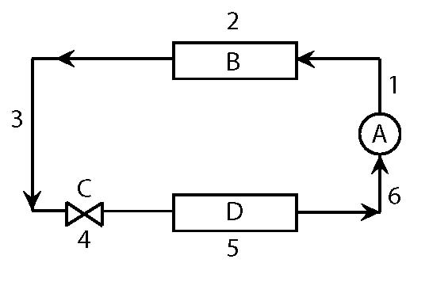
- Component A is…
- The evaporator
- The pump
- The compressor
- Component B is…
- The compressor
- The condenser
- The expansion valve
- Component C is…
- The pump
- The expansion valve
- The check valve
- Component D is a…
- Vapor lock
- Condenser
- Evaporator
- At stage 1, the media in question is…
- Gaseous
- Cold refrigerant
- Hot refrigerant
- None of the above
- At stage 2, the media in question is…
- Absorbing heat
- Giving off heat
- Creating a vacuum
- At stage 3, the media in question is…
- Still gaseous
- Still liquid
- still crazy after all these years
- At stage 4, the media in question …
- Undergoes a dramatic pressure drop
- Is subject to an intense pressure increase
- Exposed to high heat
- At stage 5, the media in question …
- Radiates heat
- Absorbs heat
- Is in the form of hot liquid
- To switch from refrigeration to vapor compression heat pump, what has to happen?
- The compressor shifts to a vacuum.
- Water must be purged from the system and replaced with refrigerant.
- The system cannot be switched.
- The expansion valve changes flow directions so the inside coil becomes the condenser and the outside coil the evaporator.
- A condenser …
- Rejects heat
- Absorbs heat
- In the absorption-refrigeration cycle, what is the “driving force” of the process?
- A heat pump
- Liquid nitrogen
- A desiccant salt
- Freon
- The absorption-refrigeration cycle is…
- A chemical process
- A mechanical process
- A physical process
- An electrical process
- Evaporative cooling is the process in which what 2 things happen simultaneously?
- Air is sensibly cooled
- Refrigerant is chilled further by exposing it to air
- Air is humidified
- Water is cooled to the point of evaporation.
- A window air conditioner is an example of…
- A chiller
- A heat pump
- An absorption-refrigeration unit
- A DX unit
- A chiller …
- Is a refrigeration unit designed to produce cold water for space cooling
- Can be operated on the vapor compression principal
- Can be operated on the absorption principal
- Is an act of sexual depravity outlawed in most states
- None of the above
- A & C
- B & C
- A,B & C
- A & C
- Once the media leaves the chiller, it is circulated to… (choose 3)
- Cooling coils located in AHU(s)
- Fan Coils
- Cast Iron radiators
- Induction units
- Duct work leading to spaces requiring cooling

- The purpose of a cooling tower is…
- To extract heat from the water that is used to cool the condenser coils of the chilled water plant.
- The mechanism by which heat removed from the building by the air conditioning system is dissipated to the atmosphere.
- Humidify the air.
- A & C
- A & B
- All of the above
- Chilled water based cooling systems are typically used in…
- Single story residential buildings
- Larger buildings
- Tee Pee(s)
- An air-cooled condenser is…
- A sensible heat exchange device where the magnitude of heat flow is a function of the temperature differential between the heat carrying media and the outside air temp.
- A latent heat exchange device where the magnitude of heat flow is a function of the temperature differential between the heat carrying media and the outside air temp.
- A hybrid DX unit that uses glycol as the heat carrying medium, and is directly cooled by outside air.
- The Coefficient of Performance is defined as…
- The amount of light given off in relation in relation to the amount of energy put in.
- The amount of noise reduced divided by the amount received.
- The cooling output divided by the energy input.
- Which 2 of the following heat rejection devices?
- Chiller
- Air-cooled condenser
- Compressor
- Cooling tower
- A cooling tower is…
- A sensible heat exchanger
- A latent heat exchanger
- A method of changing gaseous media to liquid
- Used only in the North East
- The same as a chiller
- An act of such profound perversion that is has been banned in the continental US, and most of Europe.

- A cooling tower is…
- Affected by the relative humidity of the outside air
- Not affected by the relative humidity of the outside air
- Used in conjunction with all-air systems
- Used in conjunction with all water systems
- A & C
- B & C
- C & D
- A,C & D
- B,C, & D
- B & D
- Supply duct is typically designed to operate at ______-velocity and _______-pressure.
- High, low
- Low, high
- Low, low
- High, high
- Increasing air flow velocities allows the use of _______ duct cross sections.
- Larger
- Smaller
- When would you specify a high velocity system?
- When space is unlimited, but financial resources scarce.
- When distribution space is constricted.
- Only in single story buildings of less than 3000 s.f.
- When is higher pressure in an air distribution system necessary? (Choose 3)
- In a system that is old and has degenerated over time.
- In a system that has multiple 90 degree bends.
- In a system with a long distribution path.
- In a system providing both heating and cooling.
- In a system requiring extensive media filtration devices throughout the distribution path.
- Return duct is typically designed to operate at ______-velocity and _______-pressure.
- High, low
- Low, high
- Low, low
- High, high
- True or False: High velocity systems are advantageous in that they are quieter than their low velocity counterparts.
- Regarding specific heat, which substance is the measure to which all other substances are compared (i.e.- which substance has the highest capacity for specific heat)?
- Air
- Water
- CO2
- steam
- HVAC systems can be noisy. What are 3 ways that this can be mitigated?
- For air systems, using interior duct liners/insulation
- For air systems, using exterior duct liners/insulation
- Locate equipment in areas away from occupied areas
- Place equipment on vibration isolators
- Use flexible duct connections originating from the plant
- All of the above
- B & C
- A,B, & D
- A,C,D & E
The following diagrams were shamelessly lifted from my MEEB, 6th Edition book. Use them to answer the following questions:

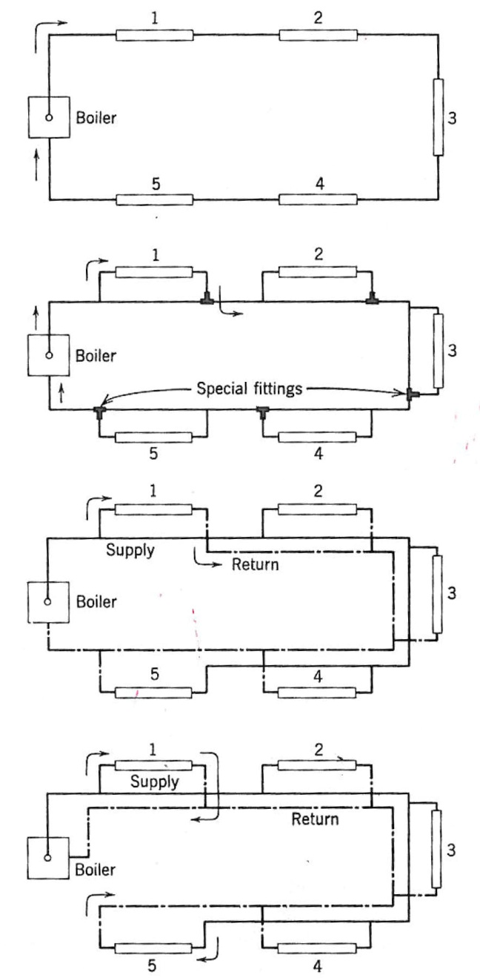
- The first diagram is what type of system?
- A single pipe, series (perimeter) loop
- The second diagram is what type of system?
- A single pipe system
- The third diagram is what type of system?
- A two-pipe, reverse return system
- The fourth diagram is what type of system?
- A two-pipe, direct return system
- Which system is the least efficient and limited in the amount of heaters it can feed?
- A single pipe, series (perimeter) loop
- Of all the systems above, which system is the most efficient?
- The two-pipe, reverse return- the spent water does not feed the following heating elements. Each element gets the same temp. water. Also, by reversing the return, equal friction resulting in equal flow is achieved through all baseboards.
- Of all the diagramed systems, which one cannot have valves attached to each unit?
- Single-pipe series perimeter loop. Shutting down one heating element would shut down the whole system…duh….
The following diagrams were lifted from the Architect’s Studio Companion
- The diagram below is an example of…
- A single duct, VAV system
- A single duct, CAV system
- A multi-zone, CAV system
- A multi-zone, VAV system
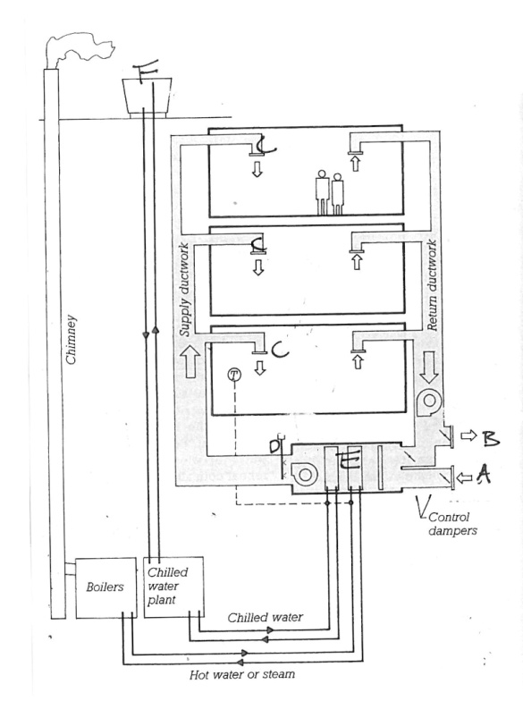
- Name components A,B,C,D,E, & F
- Supply (fresh) Air Intake
- Exhaust air
- Diffusers
- Humidifier
- Fan room
- Cooling tower
- This type of system is appropriate for…
- Theaters
- Lobbies
- Department stores
- All of the above
- None of the above
- True or False: This system permits total temperature control by individual occupants.
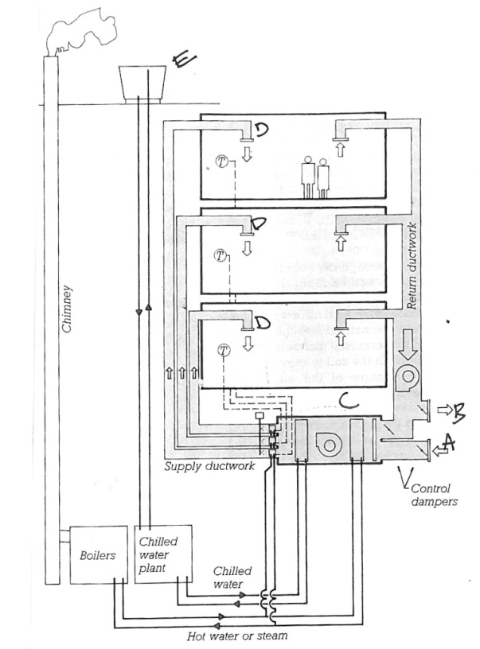
- The diagram above is an example of…
- A single duct, VAV system
- A single duct, CAV system
- A multi-zone, CAV system
- A multi-zone, VAV system
- True or False: This system permits total temperature control by individual occupants.
- True or False: This system is well suited for larger buildings with many zones.
- True or False: In this system, the air is mixed within each individual zone.
- True or False: This system the heating of one area while simultaneously cooling another no matter how extreme the temperature differential.

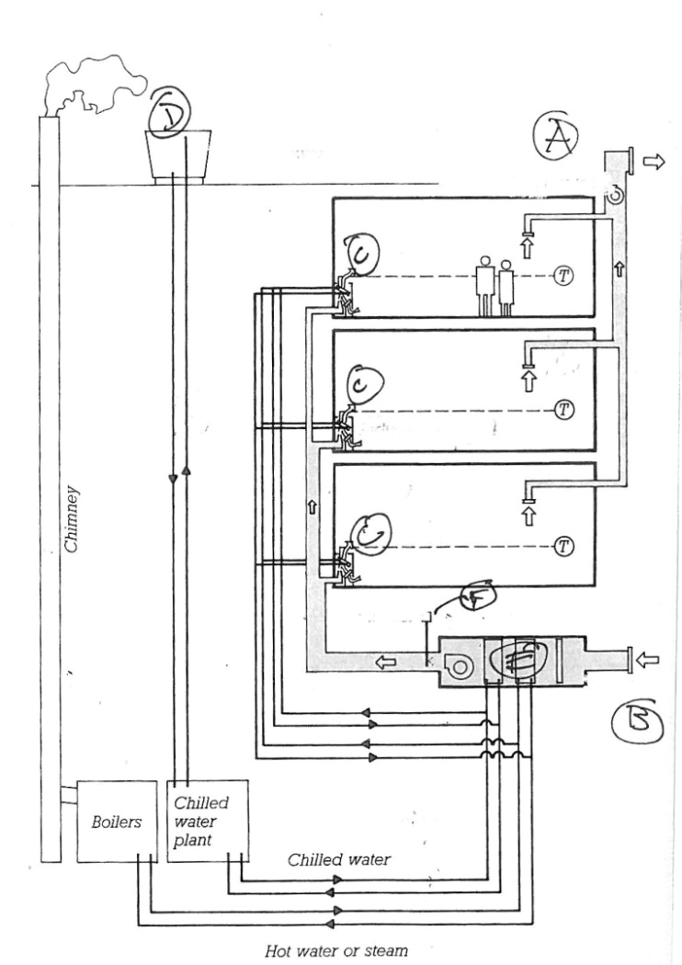
- The diagram above is an example of…
- A single duct, air-water VAV system
- A single duct, air-water CAV system
- A multi-zone, air-water CAV system
- A multi-zone, air-water VAV system
- An air-water induction system
- True or False: The air is the heat carrying medium in this system.
- The air supplied to the “space conditioning unit” is referred to as…
- Primary air
- Secondary air
- Tertiary air
- The air drawn into the “space conditioning unit” is…
- Of smaller quantity in relation to the supplied air
- Of greater quantity in relation to the supplied air
- Of equal quantity in relation to the supplied air
- The air drawn into the “space conditioning unit” is…
- The coil within the “space heating unit” is heated or cooled by…
- The water supplied, which is referred to as “secondary water.”
- The air drawn in, which is referred to as “secondary air.”
- The air supplied, which is referred to as “primary air.”
- The ratio of room air to supplied air mix within this system is…
- Room air, apx. 50%, Supply air 50%
- Room air, apx. 75%, Supply air 25%
- Room air, apx. 10%, Supply air 90%
- Room air, apx. 30%, Supply air 70%
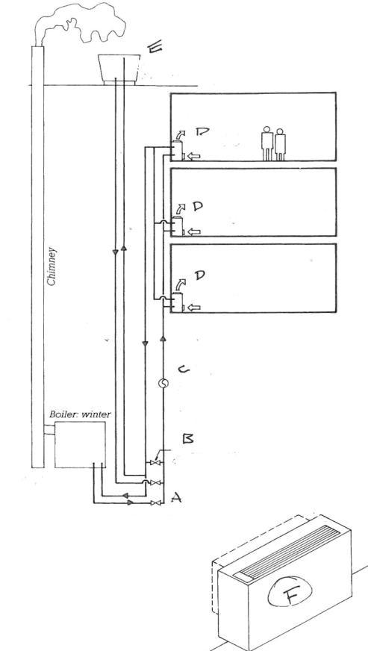
- The diagram above is an example of…
- A fan-coil terminal
- An air-water induction system
- A closed loop heat pump
- A hydronic convector
- Name components A,B,C,D,E, & F
- Control valves
- Bypass valves
- Pump
- Heat pump
- Cooling tower
- True or False: The water can bypass both the cooling tower and boiler when no heating or cooling is necessary.
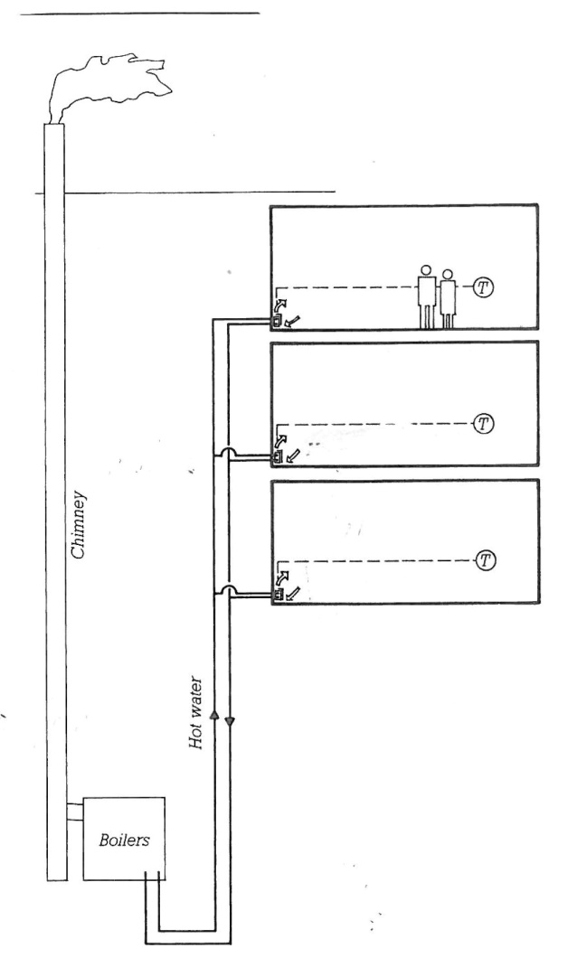
- The diagram above is an example of…
- A fan-coil terminal
- An air-water induction system
- A closed loop heat pump
- A hydronic convector
- True or False: This system can be used for either heating or cooling.
- This system works on the principal of…
- Radiation
- Conduction
- Convection
- Induction
- Which types of all air system(s) is/are capable of heating one area of a building while simultaneously cooling another?
- Single Duct VAV
- Dual Duct CAV
- Multi-Zone
- Single Duct CAV
- DX System
- Single Duct CAV w/ Reheat
- Determine the temperature @ each inside wall layer at the cavity (sans stud) of a wall section with the following characteristics: Design day= 15 degF, Interior Temp = 65 deg F
Formula is Delta T layer= (Rlayer/Rtotal) x Delta Ttotal
- Outside air film R=0.15
- Aluminum siding (who specified that?!) R=0.50
- ½” Plywood sheathing R=.60
- 3 ½” Batt insulation R=11.5
- ½” GWB R=.40
- Inside air film R=.70

